Making it as a professional dancer can be hugely competitive but using your training, there are a range of other roles you can go into beyond a career on stage. Linda Jasper, Director of Youth Dance England, offers some advice for young dancers aiming for a career in the profession.
"So, you've decided that you want a career in dance. Be under no illusions that you have selected one of the toughest career paths possible - but also one of the most rewarding.
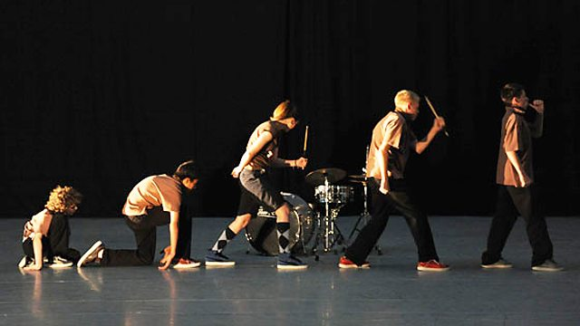
Photo: Brian Slater
Young dancers who dream of a career that is their passion often forget that the dance profession isn't just something that takes place on a stage or in a rehearsal room. Careers in dance can take place in all kinds of settings - hospitals and art centres, backstage, in schools and community centres and even in offices. In fact, you may like to know that of the estimated 30,000 people employed in the dance sector, only 2,500 are performers! 22,500 go into teaching careers and the remaining 5,000 are employed in a variety of 'support' careers such as management, therapy and notation.
Many of those entering the dance sector will start their careers as performers and then move into other areas as they mature or wish to broaden their skills. Others will discover during the course or their training that there are non-performance areas that interest them and they may wish to use their training to develop abilities in producing and project management, technical production or initiating a portfolio career. An individual with a number of skills, perhaps in performing, teaching and managing, combines these strengths and becomes a highly employable and flexible dance artist.
The one thing that unites all these wildly different strands in the sector is the commitment and dedication they all generate. Whilst a performer's career, like a footballer's, can be brief, a career, or vocation, in the dance 'industry' can last your entire working life. Use your skills and you can enjoy a life-long career in dance.
Transferable Skills
In reality, only a tiny percentage of people who train as dancers succeed as performers or choreographers. However, the huge variety of skills and techniques they have gained through their training will equip them for a multitude of other roles that can be just as fulfilling as, or perhaps more than, a performing career.
Once you have developed key skills such as discipline, motivation, creativity and team work, your dance craft can be applied creatively in many ways. It can spill into words onto a page, be snapped in a stunning photograph passed onto others through the sharing and teaching of skills. There are numerous opportunities for people who want a career in the dance industry and many of these will require different skills, picked up in a variety of situations and contexts.
Whether you choose to become a teacher, costume designer, dance therapist or a company manager, all of these roles require an understanding of dance in its many forms and all of them have an essential contribution to make to the dance world.
Best of luck with your career in dance!"
Article above taken from: http://www.bbc.co.uk/blogs/performingartsfund/entries/d5681dc1-db55-3f26-9b83-2163a0db2895
For more information go to: http://www.danceuk.org/

