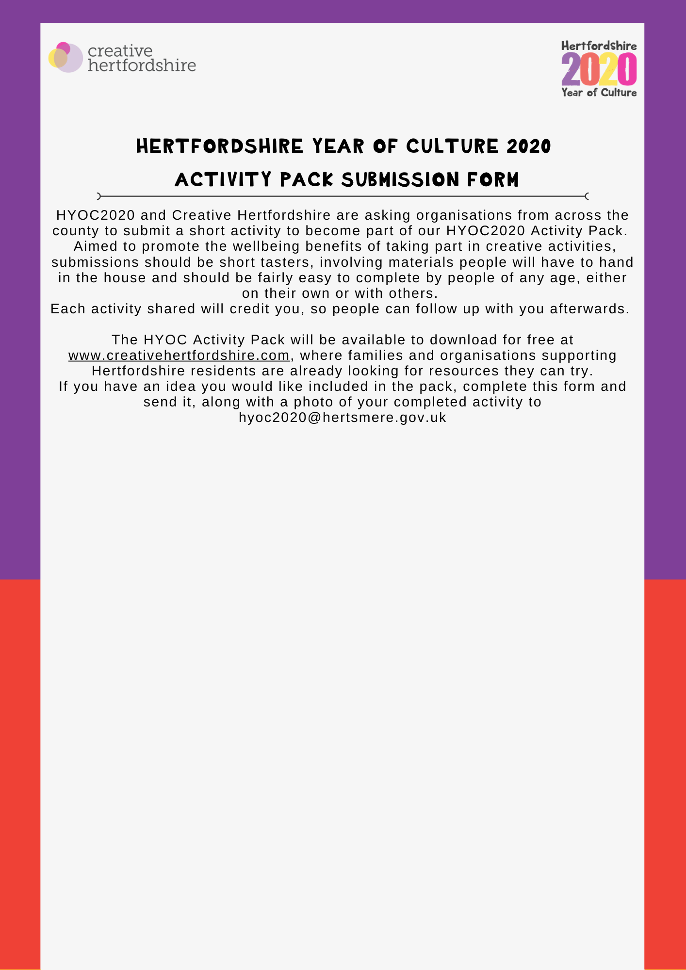

Tell us about you…
Your name:

Your organisation (and your website)

Please describe your work:

Contact details (email and phone number):
Please attach an image that you have permission to be used alongside this activity

(or attach to return email if easier)
Name of your activity
Suggested group you have already (or would) use this activity with (e.g. older people, families, intergenerational, people with disabilities…)
What comments have you had from participants (or other organisations) who have used these activities, that we could quote
Description of activity
(in up to 50 words)
Equipment or materials needed
(Please keep it as simple as possible!)
Let’s get started
(These are the simple steps to take to do the activity. Please number steps e.g. 1-4)
What’s next?
(How can people progress with this activity – i.e. use a faster piece of music, use different materials, work in larger scale, try it outdoors…)

